# Teamwork Project Assignment for the [JavaScript Advanced Course @ SoftUni](https://softuni.bg/courses/javascript-advanced)

You will be given the task to implement the core structure of a Single-Page Application (SPA). A SPA is a web application which does not depend on different web pages for control of its content, but rather on dynamic content change of a single web page.

You will be given the **main** **HTML document structure**, the **CSS styling**, and **the files from the core structure**. What you will need to do is **– implement the logic** of all the **JavaScript** **classes** and **objects** which will be used as **models** in the core structure. If everything is done correctly, the application will run without problems. You will also need to write **unit tests** at some point.

The functionality you need to implement will be divided into **several problems with descriptions**. Each of those problems will have **automated tests in the Judge system**. You are advised to organize your teamwork well: assign different problems to different people, communicate with each other in order to have synchronized work, and use **GitHub** as a version control system.

You will have two days to finish your team project. You will be given the project’s description on the first day. Each team will consist of 3 people and each team will be formed with random people.

**Important: there are several strict rules you must take in mind, in this teamwork:**

* **Each team member** must have a **GitHub account**, and he / she must contribute to the project’s development in order to be counted as a working member of the team.
* **Each team member** must have provided a way of communication, e.g. (Facebook, Skype, email…) in his / her **profile**. **Each team member** must also provide a link to his **GitHub account** in his **profile**.

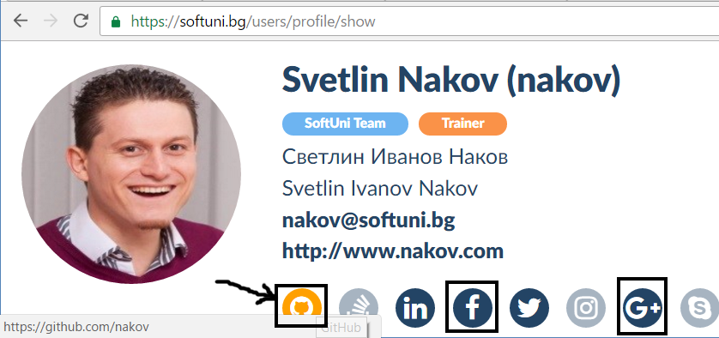

* Upon completion of the project, each member should **submit the whole project in Judge**. In other words, if you work separated on different problems, at the end, **each team member** must **submit every other’s work in Judge**, along with his / hers, so that maximum results are reached.
* If you **have submitted your results in Judge**, but you have **not contributed to your team project’s GitHub Repository**, from your very **own GitHub account**, you will **NOT** be counted in the team’s evaluation.
* If a team **lacks** a **GitHub repository**, its work will **NOT** be evaluated.
* It is **your own responsibility** to contact your own teammates and communicate with them throughout the project development process.
* If you apply to a teamwork and you refuse to work for it, or your results are nullified, due to lack of contribution to the GitHub repository, there will be **HEAVY PENALTIES** on your course final grade.
* **Excuses will not be tolerated**! It is your **own responsibility** to **provide a contact** for yourself, and to **contact your teammates** if you have not been contacted. A team which lacks communication and teamwork between the members will **NOT** be evaluated.

## General Requirements

* **Use JavaScript** – the entire work should be implemented in JavaScript
* Ensure your application **works correctly** in the latest versions of Chrome
* Use **GitHub** as a version control system and project collaboration tool
* **Work in team** – all team members should contribute
* **Do not** use **engines** or **tools** that generate the JavaScript code

## Additional Requirements

* Follow the **good practices** for writing code: correct naming, correct formatting, etc.

## Deliverables

* Each team member must submit his / her code in Judge to test if it works correctly, and commit everything he / she works on or has completed, in the team project’s GitHub repository.
* Each team member must submit the same link to the GitHub repository.

## Project Evaluation

The project’s evaluation will be done after the final deadline for submission of teamwork projects. The teamwork project’s evaluation will depend on your team’s results in the Judge System and your work in your team project’s GitHub repository.

## Give Feedback about Your Teammates

You will be invited to **provide feedback** about all your teammates, their attitude to this project, their technical skills, their team working skills, their contribution to the project, etc. The feedback is important part of the project evaluation so **take it seriously** and be honest.